Batch: A1 Roll No.: 16010123012

Experiment / Assignment / Tutorial No.: 4

Title: Implementation of PCA for Dimensionality Reduction in Correlated Datasets.
Aim: To understand & implement PCA for dimensionality reduction using python.
Expected Outcome of Experiment:
CO3: Employ unsupervised learning methods to explore, categorize data and differentiate patterns within datasets.
Books/ Journals/ Websites referred:
1. “Machine Learning”, Tom M. Mitchell, McGraw Hill, 2017.
2.https://builtin.com/data-science/step-step-explanation-principal-component-analysis
3. https://www.geeksforgeeks.org/data-analysis/principal-component-analysis-pca/
4. Python Data Science Essentials - Third Edition, 2018 Packt Publishing

Theory:
Dimensionality Reduction
Dimensionality reduction is the process of reducing the number of input variables (features) in a dataset while preserving the essential structure and information.

Reasons for Dimensionality Reduction
- High-dimensional datasets suffer from data sparsity, reducing prediction reliability.
- Increased computational cost and memory usage.
- Redundant and correlated features do not add new information.
- Visualization becomes difficult when the number of features increases.

Principal Component Analysis (PCA)
Principal Component Analysis (PCA) is an unsupervised statistical technique used for dimensionality reduction. PCA transforms the original correlated features into a new set of orthogonal (uncorrelated) variables called principal components, arranged in decreasing order of variance.
Steps to implement Principal Component Analysis (PCA)
Step 1: Standardization and Centering Data
Centering data is to standardize the range of the continuous initial variables so as to ensure equal contribution by each variable to the PCA analysis to avoid biased results.
This can be done by subtracting the mean and dividing by the standard deviation for each value of each variable.
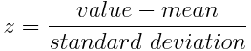
Step 2: Computation of Covariance Matrix
In the covariance matrix between vector with itself, the matrix of covariances
between the scalar components of the vector
The cross-covariance between two vectors is
The covariance matrix is a N × N symmetric matrix (where N is the number of dimensions (variables). For example, for a 3-dimensional data set with 3 variables x, y, and z, the covariance matrix is a 3×3 data matrix of this from:
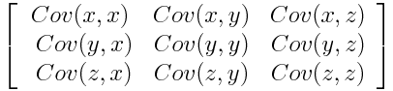
The covariance is commutative (Cov(a, b) = Cov(b, a)). Hence, the entries of the covariance matrix are symmetric with respect to the main diagonal, which means that the upper and the lower triangular portions are equal.
- If covariance value between two variables is positive then the two variables increase or decrease together (they are correlated)
- If covariance value between two variables is positive then as one variable increases, the other decreases (they are inversely correlated)
Step 3: Eigen Decomposition and Identifying Principal Components
Eigenvectors and eigenvalues are to be computed from the covariance matrix in order to determine the principal components of the data. The eigenvectors of the Covariance matrix are the directions of the axes where there is the most variance (most information) and that are called as Principal Components. And eigenvalues are simply the coefficients of the eigenvectors, which give the amount of variance carried in each Principal Component. By ranking your eigenvectors in order of their eigenvalues, highest to lowest, you get the principal components in order of significance.
Principal Component Analysis Example:
Let’s suppose that our data set is 2-dimensional with 2 variables x and y and that the eigenvectors and eigenvalues of the covariance matrix are as below:
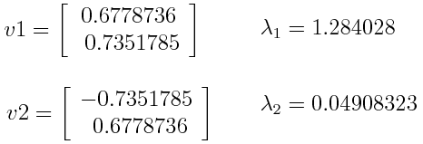
If we rank the eigenvalues in descending order, we get λ1 > λ2, which means that the eigenvector that corresponds to the first principal component (PC1) is v1 and the one that corresponds to the second principal component (PC2) is v2.
The percentage of variance of the principal components is computed (information) for each component, by dividing the eigenvalue of each component by the sum of eigenvalues. If we apply this on the example above, we find that PC1 and PC2 carry respectively 96 % and 4 % of the variance of the data.
Step 4: Feature Selection and Creating a Feature Vector
Computing the eigenvectors and ordering them by their eigenvalues in descending order is needed to find the principal components in order of significance.
The feature vector is simply a matrix that has as columns the eigenvectors of the components that we decide to keep. This makes it the first step towards dimensionality reduction, because if we choose to keep only p eigenvectors (components) out of n, the final data set will have only p dimensions.
Principal Component Analysis Example:
Continuation of the example from the previous step, we can either form a feature vector with both of the eigenvectors v1 and v2:
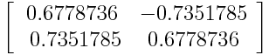
Or discard the eigenvector v2, which is the one of lesser significance, and form a feature vector with v1 only:
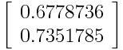
Discarding the eigenvector v2 will reduce dimensionality by 1, and will consequently cause a loss of information in the final data set. But as v2 is carrying only 4 percent of the information, the loss will be less important and we will still have 96 percent of the information that is carried by v1.
It is you to decide whether to keep all the components or discard the ones of lesser significance, depending on the application and required outcome.
Step 5: Data Projection
In this step, the aim is to use the feature vector formed using the eigenvectors of the covariance matrix, to reorient the data from the original axes to the ones represented by the principal components (hence the name Principal Components Analysis). This can be done by multiplying the transpose of the original data set by the transpose of the feature vector.
Principal Component Analysis Variants
1. Kernel PCA (KPCA) - Captures non-linear relationships between features.
2. Sparse PCA (SPCA) - Creates interpretable components and mitigates overfitting in high-dimensional data.
3. Robust PCA (RPCA) - Handles outliers and noise by separating them from the true low-dimensional structure.
4. Incremental PCA (IPCA) - Scalable to large data sets and suitable for real-time data tasks.
5. Probabilistic PCA (PPCA) - Provides a probabilistic interpretation of data and supports inference under uncertainty.
Problem Definition:
Apply Principal Component Analysis (PCA) on a real-world dataset (Pizza dataset / Diabetes dataset / any correlated numerical dataset) to reduce dimensionality and analyze the variance preserved by the selected principal components.
Reference Link for dataset
https://drive.google.com/drive/folders/1GxcvBAWrdwemDrxWBhjWEayCrcXZGaft?usp=sharing
Details of data set used: Pizza.csv
API/Function used:
pandas: read_csv, DataFrame, head, drop, info, describe
numpy: array, cov, linalg.eig, abs, hstack, sign
sklearn.preprocessing: StandardScaler
sklearn.decomposition: PCA
matplotlib.pyplot: figure, xlabel, ylabel, title, grid, show
seaborn: scatterplot

Results:
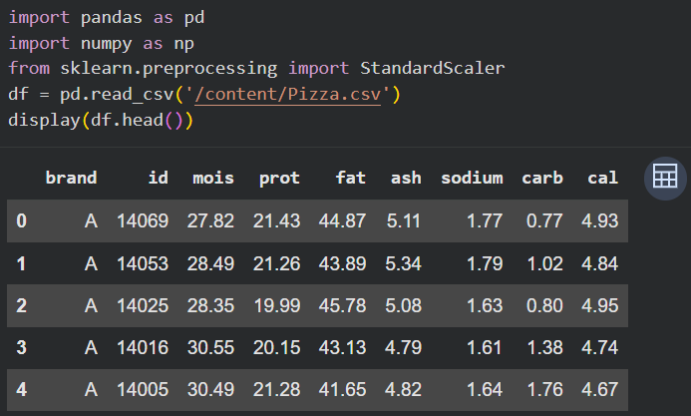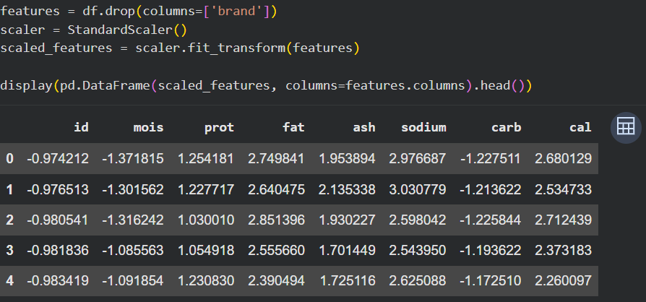
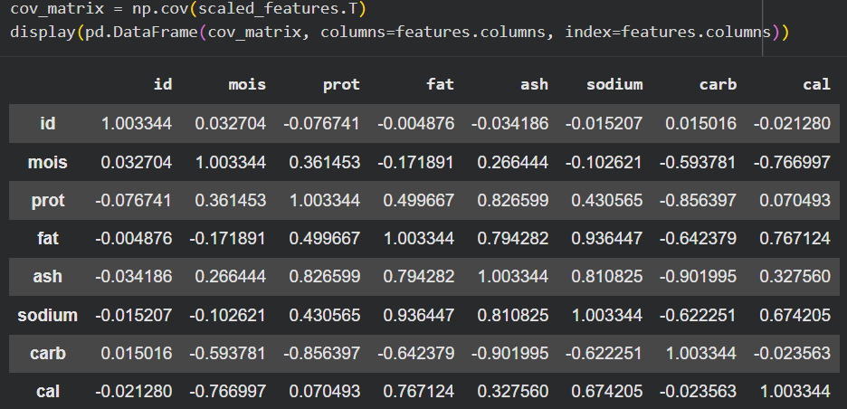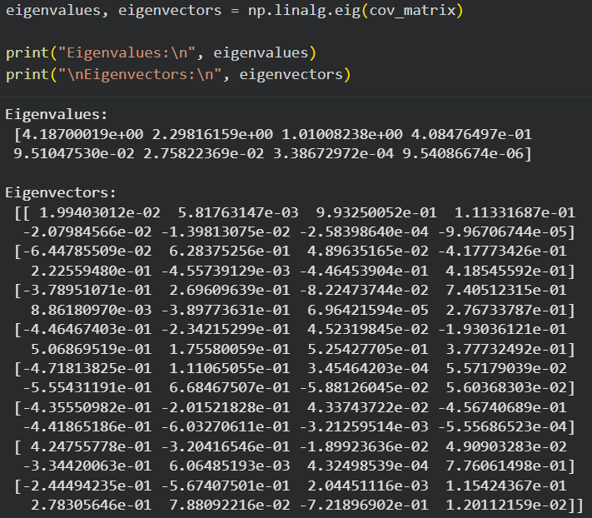

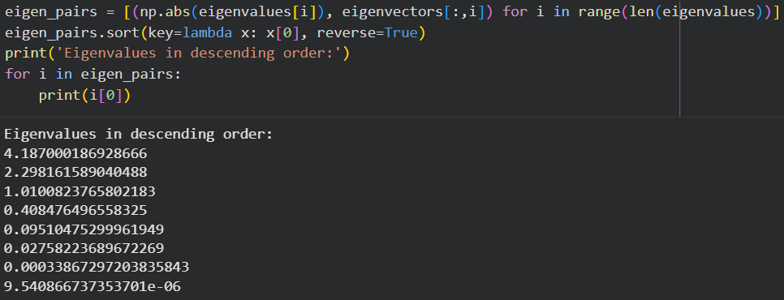
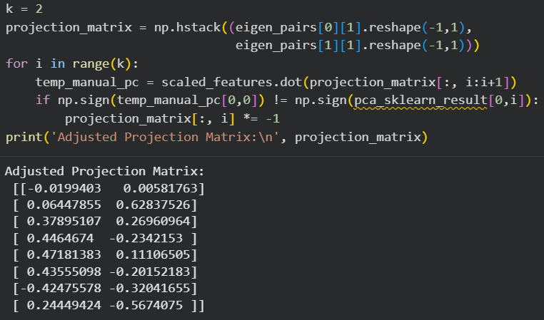
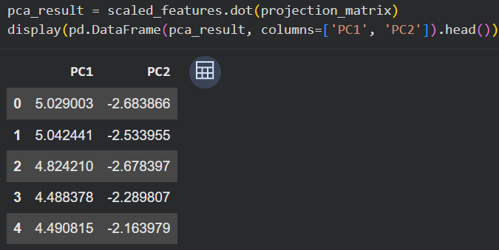
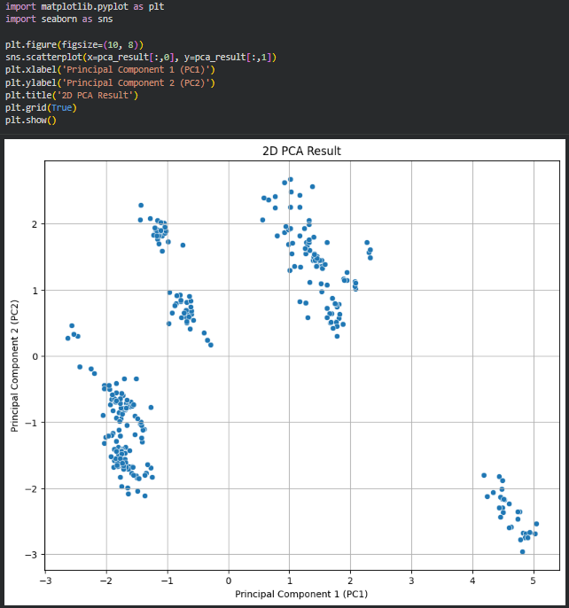

Using Direct Library
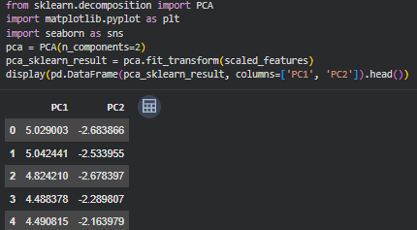
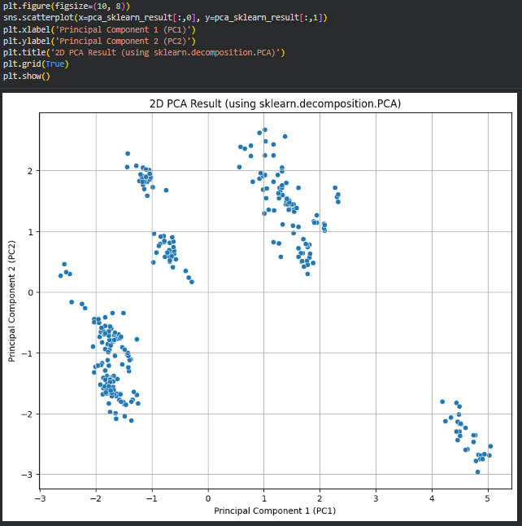
Conclusion: PCA was successfully applied to reduce the dimensionality of the dataset by transforming correlated features into uncorrelated principal components. It was observed that the first principal component captures most of the variance, allowing dimensionality reduction with minimal information loss. This demonstrates that PCA improves computational efficiency while preserving essential data patterns.

Post Lab:
- What is the role of eigenvalues and eigenvectors in PCA? How do they help in dimensionality reduction?
Eigenvectors represent the directions along which the data varies the most, while eigen values represent the amount of variance along those directions. In PCA, the covariance matrix of the dataset is computed, and its eigenvectors and eigenvalues are extracted. The eigenvectors corresponding to the largest eigenvalues are selected as principal components because they capture the maximum information in the data. By selecting only the top few eigenvectors, the dimensionality of the dataset is reduced while retaining most of its variance. Thus, eigenvalues help rank the importance of components, and eigenvectors define the new feature space.
- Given the dataset:
X={(2,1),(3,5),(4,3),(5,6),(6,7),(7,8)}
- Compute the covariance matrix of the data.
- Find the eigenvalues and eigenvectors of this covariance matrix.
Given Dataset: X = {(2,1), (3,5), (4,3), (5,6), (6,7), (7,8)}
Step 1: Mean Calculation
x̄ = (2 + 3 + 4 + 5 + 6 + 7) / 6 = 4.5
ȳ = (1 + 5 + 3 + 6 + 7 + 8) / 6 = 5
Step 2: Centered Data
x | y | x - 4.5 | y - 5
2 | 1 | -2.5 | -4
3 | 5 | -1.5 | 0
4 | 3 | -0.5 | -2
5 | 6 | 0.5 | 1
6 | 7 | 1.5 | 2
7 | 8 | 2.5 | 3
Step 3: Covariance Matrix
Var(x) = [(-2.5)² + (-1.5)² + (-0.5)² + (0.5)² + (1.5)² + (2.5)²] / 5 = 17.5 / 5 = 3.5
Var(y) = [(-4)² + 0² + (-2)² + 1² + 2² + 3²] / 5 = 34 / 5 = 6.8
Cov(x,y) = [(-2.5)(-4) + (-1.5)(0) + (-0.5)(-2) + (0.5)(1) + (1.5)(2) + (2.5)(3)] / 5 = 25 / 5 = 5
Covariance Matrix:
 | x | y
x | 3.5 | 5
y | 5 | 6.8
Step 4: Eigenvalues
|C - λI| = 0
(3.5 - λ) (6.8 - λ) - 25 = 0
λ² - 10.3λ - 1.2 = 0
λ₁ ≈ 10.41, λ₂ ≈ -0.11
Step 5: Eigenvectors (Approx)
For λ₁ ≈ 10.41: v₁ ≈ [0.59, 0.81]
For λ₂ ≈ -0.11: v₂ ≈ [-0.81, 0.59]

